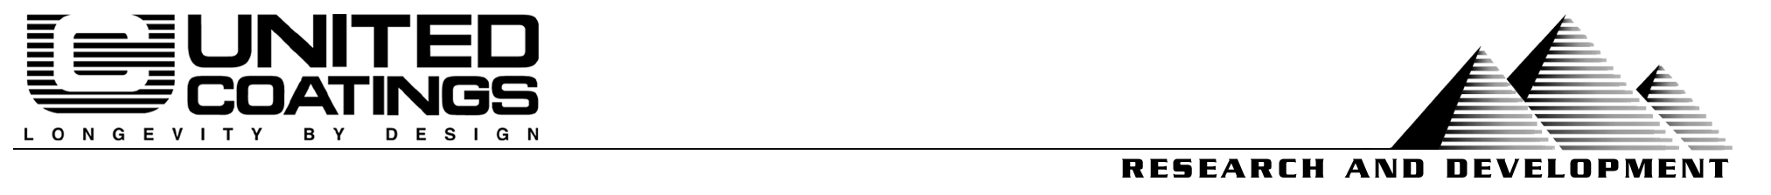
6/4/04

File #: CS 0757B
Project & Purpose:
Evaluation of Uniflex 255 by test methods that might be useful specifying and promotions of the value that these products give.
Products:
Uniflex 255 Pt A White #96834
Uniflex 255 Pt B #97231
TT-P-19D Control (Century 2000 White #97366)
Procedures:
D4060 Standard Test Method for Abrasion Resistance of Organic Coatings by the Taber Abraser
E303 Standard Test Method for Measuring Surface Frictional Properties Using the British Pendulum Tester
Ford Motor Company Method BN-108-02
Key Results:
— Friction and Abrasion Results Vs. Paint—
Test Methods →  Products↓ | Taber Abrasion  ASTM D4060 |  | Ford Scuffing Test BN-108-02 | Dynamic Friction ASTM E303
Test Methods →  Products↓ | Taber CS-17 Wheel | S-39 (Shoe Leather) | Type “B” severe | British Pendulum
Uniflex 255 | 0.077 gram wt. loss | 0.000 gram wt. loss | 0.011 gram wt. loss | 73.5
Rhino Top textured | 0.075 gram wt. loss | 0.000 gram wt. loss | 0.014 gram wt. loss | 63.3
TT-P-19D paint | 0.263 gram wt. loss | 0.000 gram wt. loss | 0.008 gram wt. loss | 50
Conclusion:
Uni-Flex 255 possesses an effective combination of anti-slip and abrasion resistant properties, even when compared to our own specialialty water based textured deck paint.
Uniflex 255 moist outstanding proprety is supplying almost 50% more grip (British Pendulum) than a flat paint as seen in our tests and about 16% more grip than our waterbased offset. The BP test starts works from the correct assumption, that people and wheels are moving objects, just ones that don’t’ want to slip when the surface is wet.
In the case of light abrasives, like urban and residential soils (CS-17 wheel / Taber) Uniflex 255 last about three timed longer than paint. It is also exceptionally resistant to wear from show leather.
It is also more scuff resistant than our textured paint as measured by an automotive seat cover test (Ford type B). We use this test to reflect on the coatings ability to handle furniture and other sharp metal edges that may be encountered in this kind of service. This reflects on the advantage of the urethane chemistry of Uni-Flex 255 which can give both more grip and still provide more scuff resistance and other forms of abrasion resistance. It does this while also being exceptionally UV stable and permanently flexible
Prepared by:
Steve Heinje | Patty White
VP Research | Compounder

